IFG Explore 2nd Year
Term One – Week Five Our Water Friends Interest

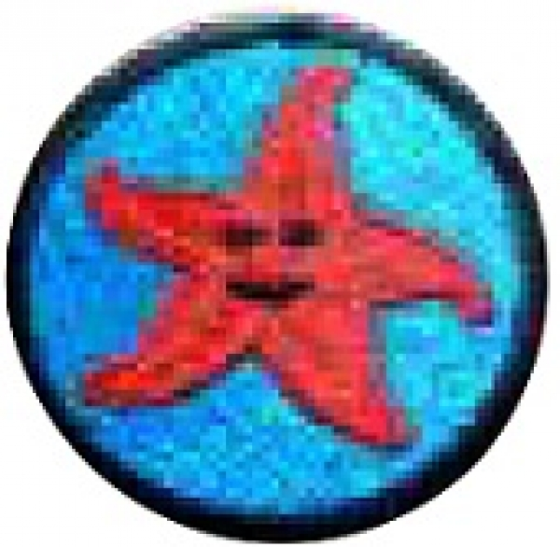
Aim: The purpose of this Award is to give the girls an opportunity to learn about our friends who live in the water.

Objective:
- Learn how to keep fish as pets at home.
- Create a fishing game
- Make a fish mobile from old CD’s

Preparation:
- Props for the devotional mime including enough small crosses, one for each girl if you choose to do the last part of the devotional.
- Organise someone to bring in a fish bowl or small fish tank as a teaching tool
- OR arrange a visit to the local Pet Shop where the girls will be able to view not only fish, but possibly turtles and other sea creatures
- Gather materials for activities:
Enough outlines of fish, one for each girl.
Enough old CD’s
Construction paper
Wiggly eyes
Wool or fishing line
Scissors
Colouring pencils or felts.
Paper clips – one for each fish.
4 small tree branches or something else suitable for a fishing rod.
String for the fishing rod.
4 magnets.
Small blow up paddling pool (optional)

Pre SetUp:
- Arrange an area for girls to view the fish bowl or tank during your teaching session.

SetUp:
Usual set up and roll call.

Devotions:

Matthew 4:19 – Read this through and use it as a mime.
“Come, follow me,” Jesus said, “and I will make you fishers of men.”
How many of you have ever been fishing? Let girls respond. Fishing is a great hobby. The Bible tells us that Jesus’ first disciples made their living by fishing. I’d love to tell you more about fishing, but I don’t have my fishing equipment with me.
Look, why, what a coincidence. Here comes a fisherman now. I guess we’ll be able to hear more about fishing after all.
Hello Mr Fisherman, we’ve just learned that some of Jesus’ first disciples were fishermen. We’d like to learn more about fishing. Can you show us some of your fishing equipment? (Points out the gear, fishing pole, hook, line, bait etc). We can fish for people today just like Jesus’ disciples did. I wonder what kind of bait we’d use to catch people? I don’t think very many of us would want to bite into a worm! (The mime looks into the tackle box, shrugs, and then olds up a $5 note and attaches it to the line) Money? You think we could catch girls for Jesus by offering them money? What do you think girls? Let girls respond.
I don’t think money will work. What other kinds of bait do you have in your tackle box? (The mime pulls out lollies and begins to attach them to the line). I know girls like lollies but too many lollies can make a person sick. Do you think people would come to Jesus if we offered them lollies? Let girls respond.

I’m sorry, but candy won’t work either. (The mime frowns) What else do you have in your box?
(The mime thinks for a moment and then smiles and pulls out a paper plate happy face). A happy face? You think people would come to Jesus if we promised that they’d always be happy? Maybe. But I don’t think we should make people that promise. We might not be able to keep it. What do you think girls? Let girls respond.
So far, our bait supply won’t catch us many people, do you have anything else in your box? (The mime olds a light bulb over her head to signify an idea and then pulls out a large cross and attaches that to her finishing line.)
The cross, of course. God uses the cross to bring people to Jesus. God loves us so much that he sent his only Son to die for us. If we believe in Jesus, when we die we’ll go to live with him forever. The cross is the only bait that will really catch people for Jesus. When we tell others that Jesus loves us so much he was willing to die for us, they’ll want to get caught too. (The mime looks very proud).
Optional piece as you will need enough small crosses, one for each girl:
Do you think our friend has any more of that bait? (The mime looks into the tackle box and then pulls out some small crosses). Let’s each take one of these little crosses home this week. Use your cross to tell a friend about Jesus’ love, and then you’ll be a fisher of people too.

Teaching Session:
The topic this week is how to keep fish healthy in a fish tank or fish bowl at home as a family pet.
If you have been able to arrange a visit to the Pet Shop, they will be able to share information with the girls on how to keep fish.
If you are doing it yourself, below are some notes to help you with this.

If you plan to have a fish as a pet you will need:
For small fish:
- A fish bowl
- Fish weed to provide oxygen for the fish
- Small pebbles for the bottom of the bowl
- Maybe a couple of rocks as a hiding place for the fish.
- Fish food – most fish only need a pinch of food each day.

For larger fish:
- A fish tank large enough for the fish to swim round freely
- You will need a filter to process the fish's waste into less harmful forms between your water changes.
- You will also need to provide hiding places for the fish, so that the fish will feel comfortable and will not feel exposed and vulnerable.
- Fish food.
Tropical fish:
- Tropical fish need a heater to keep the water warm to mimic the tropical conditions these fish are from.
Once the tank is set up the fish need to be cared for, to do that you will need to:
- Provide regular cleaning of the bowl or tank and water changes.
- If you have a filter this will need to be kept clean and maintained.
- Provide daily food for your fish.
- Observe the fish regularly to make sure they are looking healthy.
As you can see caring for your fish and keeping them healthy is quite simple but you do need to have a routine for feeding etc.

Activities:
There are two activities so the girls can be divided into two groups, one group to work on the fish for the fishing game while the other group makes their fish CD – groups then swap over to do the other activity.
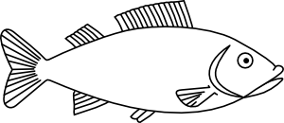

Fishing Game
For this fishing game have enough paper fish, one for each girl (outline attached).
Girls’ are to colour in their fish then attach a paper clip somewhere on its body.
Each fish now needs to have a number written on it, 5, 10, 15, 20 etc. there can be several of the same number.
Each group of girls needs to make two fishing rods out of the tree branches and string and tie a magnet on to the end of the string.
Set these aside now until the other group has completed their fish.
It is suggested that you finish the evening with this game.
How to play:
Put all fish in the paddling pool (or could be in several large bowls or other suitable containers), girls now use the fishing rods with the magnets on the end of the string to “catch” the fish. Each team takes a turn and the number on each fish is kept as a score for that particular team.
You may like to have some chocolate fish as prizes for this game. (The Warehouse has bags of spratz which are great as prizes).
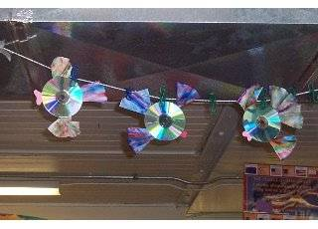
Fish out of old CD’s:
Equipment needed:
- Two old CD’s for each girl.
- Construction paper – various colours
- Wiggly eyes
- Craft glue
- Yarn or fishing line
- Scissors

Instructions:
- Using construction paper cut out the fish's lips, fins, and tail.
- Glue the lips and fins to the side of the CD with the writing on it.
- Set aside one of the top fins.
- Cut a piece of yarn or fishing line to desired length, enough to hang the fish up with, tie a knot in one end.
- Run a line of glue from the hole in the centre of the CD up to the top edge of the top fin that is glued onto the CD.
- Lay the yarn or fishing line on top of the glue so the knot is in the hole in the CD.
- Glue the extra top fin on top of the other top fin to cover the yarn.
- Spread glue all over the side of the CD that everything else is glued to.
- Set the other CD on top of the glue and match up all the edges.
- Make sure you have the side of the CD with any writing facing down into the glue.
- Glue the wiggle eyes on your fish as shown. Glue one on each side of his head. If you don't have wiggly eyes, you can also use a small white pom-pom and a black bead. This will give your fishes eyes a more 'buggy' look!
- The last thing you need now is a fin on the side of the fish! You will make these by using a 5 x 6 inch piece of construction paper.
- Accordion fold the paper. Once it is fold, hold the folds together and slip in through the hole in the centre of the CD.
- Centre the paper in the hole and unfold the ends a bit to fluff them out.
- Add a little glue to hole of the CD and the paper.
- You can now hang up your completed fish.

Finish the evening with the fishing game.

Closing Prayer

Notices:
Hand out notices with the necessary information for next week’s visit to the beach or the river.
Decide whether the girls will be able to have a swim next week and if so, they will need their togs.
Ensure you have the required leader/girl ratio of 1 to 4 since it is a water activity.

Home

IFG Explore 2nd Year
Term One – Week Six Our Water Friends
Aim: To look at, and learn about life in rock pools or in the river.

Objectives:
- To check out the rock pools and fish life and other small creatures at the beach
- OR Visit a river to look at the fish life

Preparation:
- Make arrangements for transport to the beach or river.
- Check your Leader/Girl ratio of 1 to 4.
- Gather together any equipment you will require eg for water volleyball, plastic bags to put shells in, any other games equipment.
- If you are going to the river you will need the equipment to make the “gadgets”

SetUp:
Since you may have decided to meet at the beach or river, mark those present as soon as they arrive.
While you are waiting for all girls to arrive, one Leader to organise a game of water volleyball.

Water Volley Ball
Equipment:
A volleyball or badminton net,
Two old towels and water balloons
How to play:
Divide into two teams and stand on opposite sides of the net.
Two members from each team at a time hold one towel.
Place a water balloon in the centre of one team's towel.
The idea is to toss the balloon over the net, into the other team's towel.
It helps to do a countdown to the toss: "One, two, three...Up!"

Devotions:
Your choice tonight or you may just want to open with prayer.

Teaching Session:
As an introduction tonight share the following with the girls.
Counting the fish in the sea
Some scientists believe that there is a growing shortage of fish in the sea. They believe the reason is that we have captured too many fish. This is called "overfishing." To help prevent overfishing, the government has to set limits, called "quotas", on how many fish fishermen can catch in a year. In order to decide on quotas, the government needs to know the total number of fish that live there. They rely on scientists to find out. But how can scientists tell? They couldn't possibly count every fish, especially when they can't see them all. The ocean is so big and fish spend all of their time underwater! The truth is, scientists don’t count every fish, instead they count so many in one area, then make an estimate using basic math.One method some researchers use is fairly simple. They go out in boats, catch the fish, place "tags" on a certain number of them, and release them back into the ocean. One week, for example, they will tag twenty fish. The next week, they will return to the same area of the ocean and count every fish they see. Maybe they will see and count two hundred. Out of that two hundred, they find that ten of those fish have tags on them. They can assume that if they saw another two hundred fish, they would find the other ten tags. They can then estimate that there are about four hundred fish living in that habitat.
Before moving onto the activities, share with the girls what your expectations are in regards to safety for this session.
Activity One:
Now let’s have a look in the rock pools at the beach, did you know:
- A rock pool can be the home of many sea creatures.
- Rock pools hold seawater even when the tide has gone out.
- Rock pools are found in the intertidal zone, which means they are covered in seawater when it is high tide and exposed to the wind and sun at low tide.
- A rock pool is like a little community, this is called a habitat.
- What lives in a rock pool depends on the rock pools size and position on the beach and the animals that live or inhabit that shoreline.
- In New Zealand you will usually find sea anemones, small shellfish, periwinkles and cats eyes, starfish, barnacles, crabs, different types of seaweed and maybe some small fish.
Did you know?
- The creatures in each rock pool depend on each other for survival. Some eat their neighbours, some eat the prey that is attracted by their neighbours and others eat the scraps that are left behind by their neighbours.
- The creatures that live in the intertidal zone need to be pretty touch because they are battered by the incoming waves and have to cope with huge changes in temperature.
- A few years ago the rock pools on our coastlines held a wider variety of sea creatures but they are being stripped off by humans.

Investigate a rock pool:
- Check out the rock pools and with the girls make a list of the different creatures that are living in the rock pool and how many there are of each.
- If you don’t know their names, describe them.
- The girls could draw a map showing where the creatures are in the pool.

Activity Two:

Create a Gift from the Sea (instructions for these are in Week 3)
Take a walk along the beach and get the girls to collect seashells which they can make into a paper weight next week.
OR collect some containers of sand to make a sand paperweight,
OR you may have your own idea of what can be collected and created into a piece of art.

Finish the evening off with a swim (if weather permits) and games.
River option if you are unable to visit a beach:

Equipment:
- Materials to make sieve’s as listed below, two girls could make and share the one sieve.

Safety:
Before moving onto the activities, share with the girls what your expectations are in regards to safety for this session.
First, share some basic facts about rivers:

Stream and river life
Our streams and rivers are home to many types of native fish, as well as freshwater crayfish (koura), shrimps, and invertebrates. Our aquatic plants and animals are under threat from habitat loss and introduced pests.
Over the last hundred years, native fish populations have decreased dramatically, mainly because of changes to their habitat. One native fish, the grayling, has become extinct.
Many of our native fish travel between freshwater and the sea as part of their life cycle. Structures such as over-hanging culverts and dams can block fish access. Land drainage, flood protection schemes, and introduced pest fish can also affect our native fish.

Aquatic plants
The aquatic plant communities in rivers and streams are made up of algae, mosses, and submerged plants with leaves. Before European settlement, most waterways were very shady because of the native forest surrounding them and supported a range of native aquatic plant species. Now most of our streams and rivers are in developed catchments and are dominated by introduced plants such as the oxygen weed, Egeria.
These introduced plants can provide instream cover for other plants and animals, but when stream flows are low during summer they can reduce the dissolved oxygen in lowland agricultural streams.

Threats to life in our rivers
Before European settlement, New Zealand's rivers and streams flowed from the mountains to the coast through native forest and grassland communities. These forests and high altitude grasslands kept our smaller rivers and streams cool and shady. The clearing of this vegetation has made stream temperatures more variable, and less suitable for many of our native aquatic animals and plants.
Activity One:
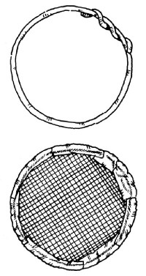
©
Check out what is in the river:
You'll be amazed by all the things that travel down the watery highway of a creek or river!
Make this gadget and see what you can catch.
Equipment:
- Wire coat hanger or piece of strong wire
- Screen or mesh
- Duct tape
How to make:
- Bend a wire coat hanger into a rough circle.
- Take a piece of old screen, and bend it around the coat hanger. (Be careful not to stick yourself with the screen. You may want to wear work gloves or gardening gloves while doing this.)
- Apply duct tape to hold the screen in place.
- Put the screen into the current and hold it there for a few minutes.
- Take out the screen and see what the current has carried onto it.
You might find seeds that will land on the creek's bank and grow into plants. Or, you might find water animals such as insects, minnows, or crayfish. (Put them back in the creek right away, so they stay alive.) You might even find something somebody lost a long way upstream!

Activity two:
Collect rocks to make a pet rock or paper weight next week.

Finish the session with a swim (if weather permits) and some games.

Closing Prayer:

Notices:

Home:

IFG Explore 2nd Year
Term One – Week Seven Our Water Friends

Objectives:
- Make the crafts –
Sand paperweight
Shell paper weight
Pet rocks
Or Rock paper weight
- OR if you weren’t able to collect the above, there is a cool octopus craft the girls can make
- Fishing games

Preparation:
- Gather materials needed for craft activities
- Fishing game – you made this equipment in the first week

Pre SetUp:
- Set up area for making the crafts
- Set up fishing game

SetUp:
Usual set up for roll call etc.

Devotions:
Bible text: Everyone who hears My words and does not obey them is like a foolish man who built his house on sand (Matthew 7 : 26)
Preparation: You will need a bucket of sand and a large rock. Put some paper or canvas on the floor to catch any sand you spill.
How many people here have ever played in the sand? Do you like playing in the sand? Why? Let children respond.
If you live near a lake or an ocean, it’s fun to sit on the sandy beach and listen to the water. Or you can build a sand castle or just dig in the sand until you reach water. If you live near a sandbox, you can drive toy trucks around in the sand or build sand buildings.
But sand is not very good for building real buildings. Here, take a little bit of sand in your hand. Pour some sand into each girl’s hand. Why wouldn’t we want to build a real building out of sand? Let girls respond. Most will probably say that sand is too soft or too light.
Sand is soft and light, but sand also moves. If you build a house on sand and then the sane moves, what will happen to the house? Let girls respond. It would be silly for someone to try to build a house on sand because the house would just fall down.
Read the text: Jesus says if we hear his message and don’t do it, we’re just as silly as a person who tries to build a house on sand. Living our own way is “sand living”.
Just listening to Jesus isn’t enough. Jesus wants us to do what He says. Jesus says “Love your neighbour” and we love them. Jesus says, “Feed the hungry” and “Heal the sick”, so we take care of those people. When we do what Jesus says, we’re building our lives on a very solid foundation. Have the adult helpers bring in the rocks, place your foot on them. Just like these rocks, they won’t move like sand does. Let’s do what Jesus says and live our lives God’s way. That’s “rock living”!

Game:
Go fishing again, have competitions between teams with a final “fish off” to see which team can score the highest. You could give out chocolate spratz for prizes.

Teaching Session:
Activites:
Choose which option suits your group – it depends on whether you have collected the necessary materials on your visit to the beach or the river.

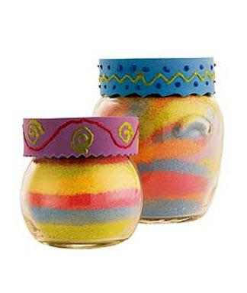
Sand Paperweight:

Equipment:

Sand

Small glass or plastic jars with lids

Coloured chalk

Sandpaper

Stickers and markers

How to make:

Use the sandpaper to rub the coloured chalk until it becomes power.

Mix powder with sand, keeping each colour separate.

Add sand one colour at a time to the jars until full.

Tap bottom of bottle on a hard surface to settle the sane. Add more sand to completely fill.

Put lid on bottle and decorate using stickers and markers as desired.

Seashell paperweight:
Equipment:
- Seashells collected last week.
- Plaster of Paris
- Food colouring
- Round plastic container or any shape, size suitable for a paper weight.
How to make:
- Mix plaster of paris to the consistency of paste (there should be instructions on the packet).
- Add a few drops of food colouring to get the desired colour.
- Pour this mixture into the plastic container.
- Press the shells into the plaster, any design you wish.
- Allow this to set – probably till next week, and then carefully remove the plaster paperweight from the tub.
- Admire the shells – a gift from nature to enjoy all year round.

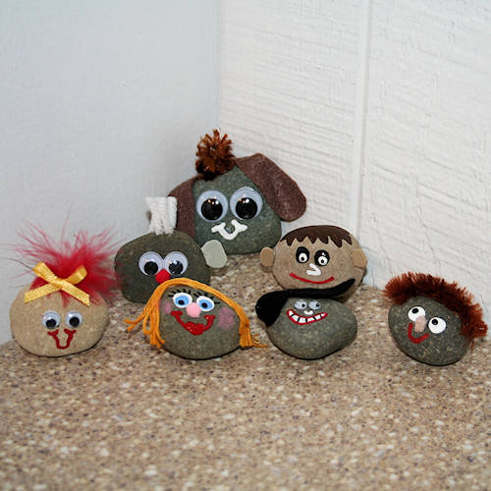
Pet Rocks:
A pet rock is a great alternative for anyone who wants a pet but does not have the space or time to take care of one. It is also a perfect pet for bad economic times because you do not have to spend money on food, vet visits, and toys. Find out how, using a rock and some basic craft supplies, you can create your own pet with lots of character!

Rock Paperweight
Equipment:
- 1 rock about your palm size and heavy enough to weight down paper. Make sure the rock has a smooth finish.
- Acrylic paint
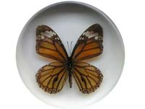
- Paint brush
- Glitter glue
- Acrylic sealer spray
- Black marker
How to make:
- Wash the rock with warm soapy water. With the help of a brush scrub it well. Make sure to get into all the crevices. Later, wipe off water with a towel.
- After the rock has completely dried, paint the entire rock with acrylic paint. Give a second coat after the paint completely dries.
- Paint the entire rock with a thin layer of glitter glue and then let dry.
- With the help of a squeezable glitter glue bottle carefully write "You Rock" or any message with just two or three words
- OR put some stickers on to decorate the rock.
- Instead of writing the words with glitter glue, you can even try a paint pen as they write like a pen but give the look and feel of a paint. Let it dry overnight.
- If needed, use a black marker to outline the letters to make them stand out better.
- Before you keep it to display spray the entire surface of rock with acrylic sealer spray. After it dries, your paper weight is ready to be used.

Optional craft if you do not have the resources for the above:
Wool Octopus:
The finished craft makes a great source of inspiration for young imaginations to make up stories about their particular octopus.
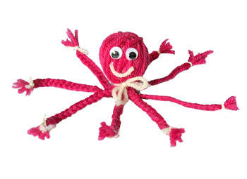
Equipment:
- Wool in two different colours
- 2-3 cotton balls
- Glue
- 2 medium wiggly eyes
- Ruler
- Scissors
- White craft glue.

How to make it:
- Choose one of the wool colours and cut into 24 pieces that are 30 cm long each.
- Lay pieces of wool on a flat surface in the shape of a wheel so that each piece intersects with the others in the centre of the wheel.
- Hold 2-3 cotton balls (2 if large, 3 if small) and roll them in your hands to create a ball about the size of a ping pong ball. Place the cotton in the centre of the wheel.
- Gather all the ends of the wool wheel snugly up around the cotton to form the head of the octopus.
- Using a piece of the second colour of wool , tie a knot around the wool gathered around the cotton ball. Tie in a knot to secure and then tie a bow and trim the ends.
- Turn the octopus right side up. Separate the wool into groups of six strands. Braid each group of six (in each group of six you should be braiding three sets of two strands)--you should have eight braids when you are finished. Tie each braid with a piece of the second colour wool. Trim the edges of the tied wool and the ends of the braids.
- Glue two wiggle eyes on to the head above the bow tie.
- Glue a piece of second colour wool for the smile.

Closing prayer
Notices
Home

